Bahria University,

Karachi Campus



LAB EXPERIMENT NO.

___05___

LIST OF TASKS

|  |  |
| --- | --- |
| TASK NO | OBJECTIVE |
| **01** | While utilizing the Linux commands studied so far, provide an example *(other than the one shown in this Lab)* of a combination of several Linux commands in which pipes are used more than once. Also provide a snapshot of the generated output. |
| **02** | Write C program to print all alphabets from a to z using while loop.(using ASCII). |
| **03** | Write a shell script that either performs a file sort, file search or directory listing operation based on the user’s selection of the operation he/she would like to execute. |
| 04 | Write a C program that asks the user to provide an integer input in the *main()* function. The program would call a function *even_odd()* from the *main()* function, where the function *even_odd()* accepts an integer as an argument, determine and display if the passed integer is either even or odd. |

Submitted On:

06-04-2023

(Date: DD/MM/YY)

**Task 01:** While utilizing the Linux commands studied so far, provide an example *(other than the one shown in this Lab)* of a combination of several Linux commands in which pipes are used more than once. Also provide a snapshot of the generated output.

**Output:**





**Task 02:** Write C program to print all alphabets from a to z using while loop.(using ASCII)

**Solution:**

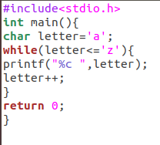

**Output:**



**Task No. 3:** Write a shell script that records the full path of all the files present within a directory into a record.txt file. Along with full path name, the script should also record the number of words, characters and lines within each file

**Solution:**

#!/bin/bash

cd /

for file in home/mutayyab/Desktop/Important/*.*

do

wc -c $file >> output.txt

wc -w $file >> output.txt

wc -m $file >> output.txt

wc -l $file >> output.txt

done

cat output.txt

**Output:**

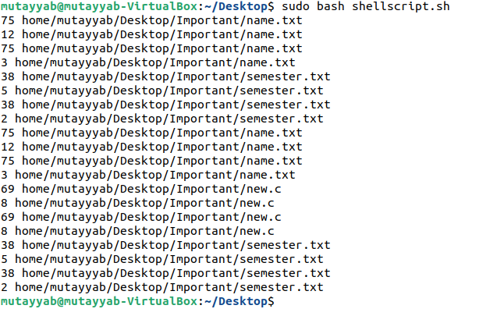

**Task No. 4:** Write a C program that asks the user to provide an integer input in the ***main()*** function. The program would call a function ***even_odd()*** from the ***main()*** function, where the function ***even_odd()*** accepts an integer as an argument, determine and display if the passed integer is either even or odd.

**Solution:**

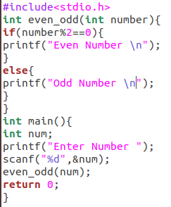

**Output:**

